Assignment#3 – Drawing Program

Purpose: To explore the remainder of the basic Win32 components (child windows, menus, dialog boxes, and the clipboard).

Requirements:

The canvas area of the window should be fixed to 1600x1200 while the window size must be fixed to 800x600. Scrollbars will allow the user to move around the canvas. Users may also draw using the “arrow” keys and shift button (which acts like the mouse click). Note that users may drag their mouse past the limits of the window, please make sure you can still capture the mouse movements as necessary (for lines only). Drawing should be handled by your own drawing function. WM_PAINT should just call your drawing function if an update is needed (passing each object needed to be drawn), otherwise drawing should occur without invalidating or updating the window. You will need to store the objects drawn in a stack for redrawing.

Lines: user clicks start location and moves the mouse with a line following behind the mouse cursor. When the user clicks a 2nd location the line is completed

Rectangles: drawn similarly to Lines.

Optional (Polygons):
Polygons: user clicks the start location and moves the mouse with a line following the mouse cursor. When the user clicks a 2nd location a line is fixed and now when the mouse is moved again a 3 point polygon is created (dynamically changing as user moves mouse). As the user clicks the mouse the number of points of the polygon increases. Drawing stops when the user clicks within 9 pixels of the start location. See the example program.

- Users set the desired drawing colour using the colour dialog box.
- Users can draw lines, rectangles, and polygons.
- Users can select an object drawn and copy it then paste (multiple) copies to a new location(s). Selection is done by the user clicking on a drawn object. For a line that means either end of the line within a 4 pixel radius. For a rectangle it means anywhere inside the rectangle. Pasting is done at the last place the mouse was clicked. Polygons are not required to be selectable. The clipboard must be used to hold the object. You will need to use your own clipboard format.
- Users use menus to select the colour, tool (selection tool, line drawing tool, etc.), toolbox.
- Users can also use a modeless dialog box to select the drawing tool (radio buttons) and call up the colour dialog box (button)

See example program for further details.

Marking Guide

Colour selection 10%
Scrollbars 10%
Copy/Paste 25%
Dialog box 20%
Menus 15%
Commenting: 10%
Style: 10%

The following is an EXAMPLE only. You must have similar functionality but you may organize your menus and GUI differently.

Below shows the Toolbox Opened. NOTE THAT THE RADIO BUTTONS AND MENU ITEMS ARE SIMILARILY CHECKED. You should be using checked menu items for the tool selected. You’ll need to message between the toolbox and menu to keep them up to date. The tool “Select” is for selecting objects (rectangles or lines).

To change the colour of line or fill colour the toolbox button “Colour...” will open the Colour Chooser (see page 5). You may instead create your own colour chooser. Instead of a standard button you may choose to use a Checkbox.

If the Close button is pressed on the toolbox the toolbox is hidden.

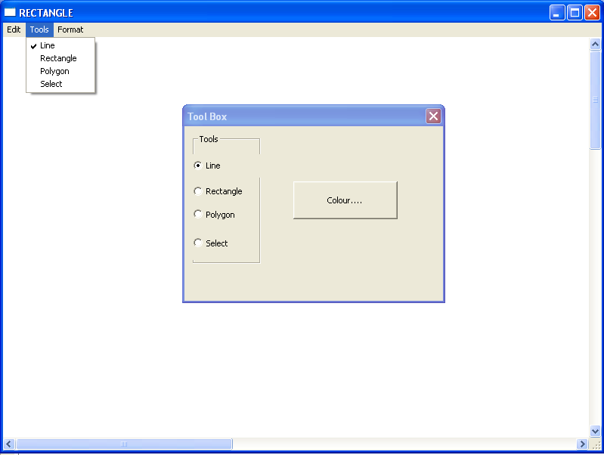

Below demonstrates how to show the Colour Chooser or Toolbox using the menu.

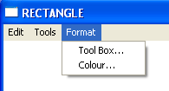

Below shows the Copy and Paste options.

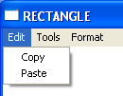

Copy and Paste MUST WORK ACROSS PROCESSES. This will be tested via two copies of your program running at the same time, one will have an item selected and pasted onto the other process.

Please make sure you indicate WHICH item has been selected (if any) using a dotted outline, XOR, colour inverse, or other such technique (you are creating a GUI tool, it should be USER FRIENDLY). You do not need to worry about screen refreshing between a selection and another action.

If you grey out options, do not grey out Paste OR when ever you gain focus check the clipboard to see if there is anything available of your type and set the Paste option accordingly.

Below show the colour chooser dialog box. Users can select the colour for the filled shape or line from this dialog box. The user can call the colour chooser from the menu or the toolbox.

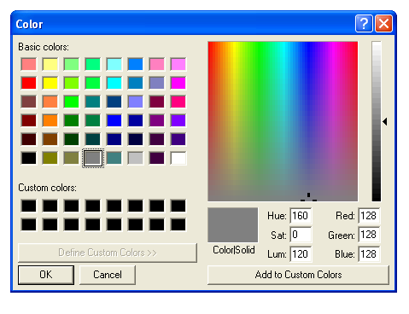

Note: for some reason the short cut keys using “Alt” do not show up from a PrtScrn.

Assignment#3 is due November 16, at 11:59PM

